How to open a Shurfersal account

- Shufersal website:
https://www.shufersal.co.il/online/
- In order to register a new account, press the "הרשמה" button.
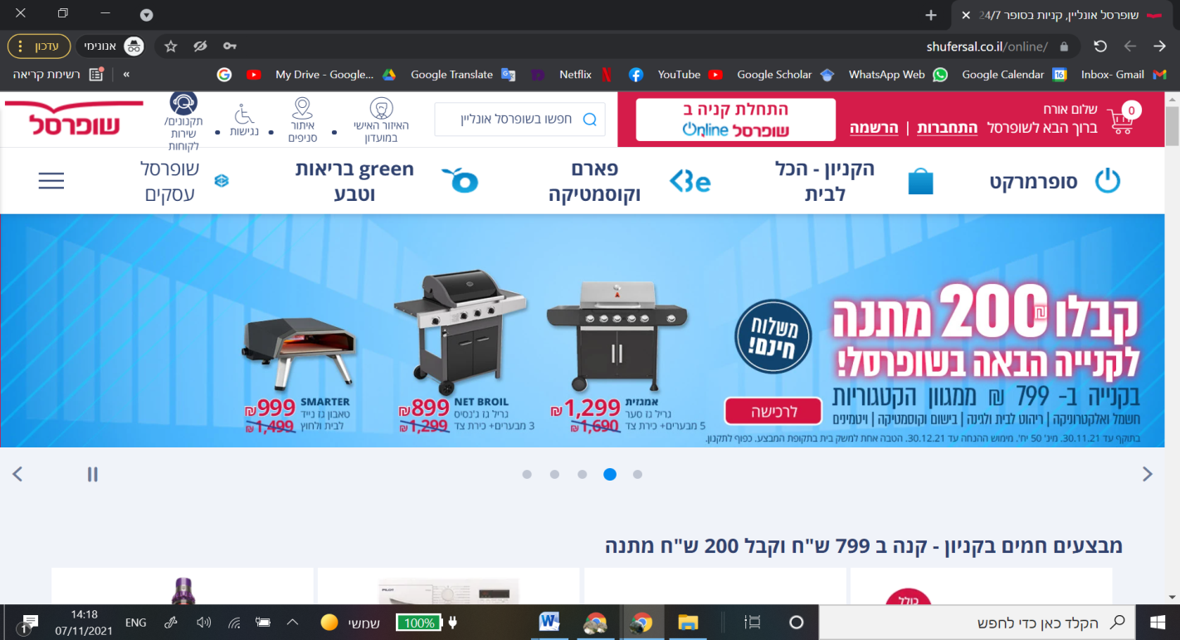

- Add your personal info:
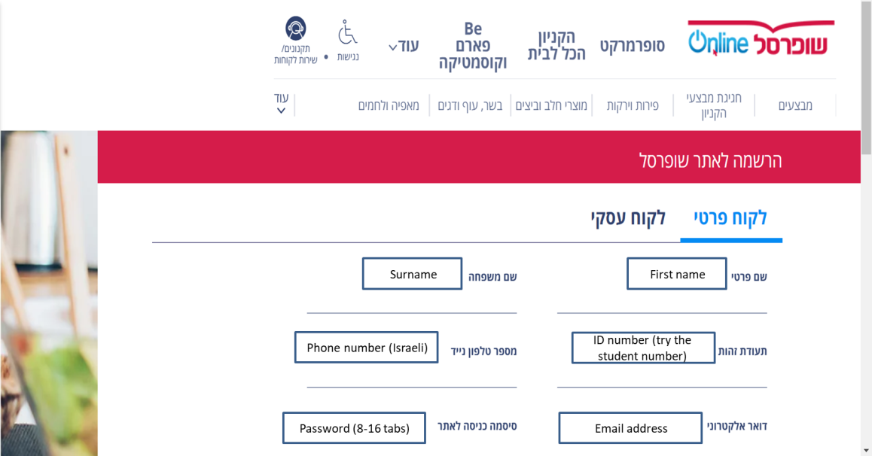
- And un-tick the boxes at the bottom. Press Save at the bottom (red button).
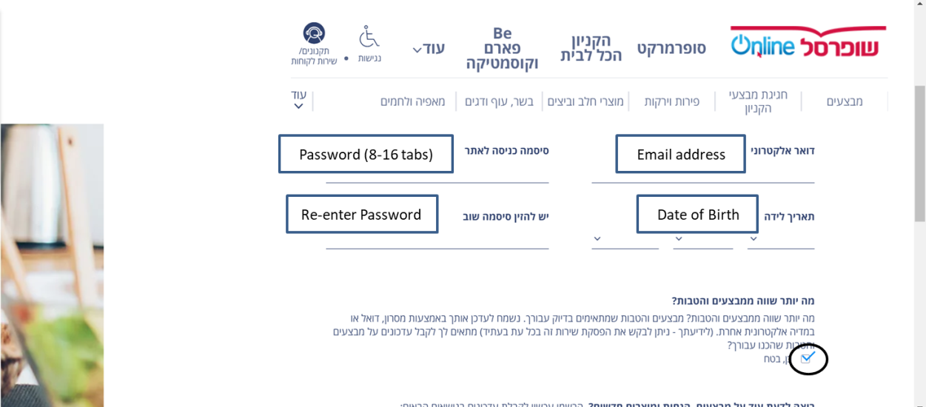

- Press "personal information":
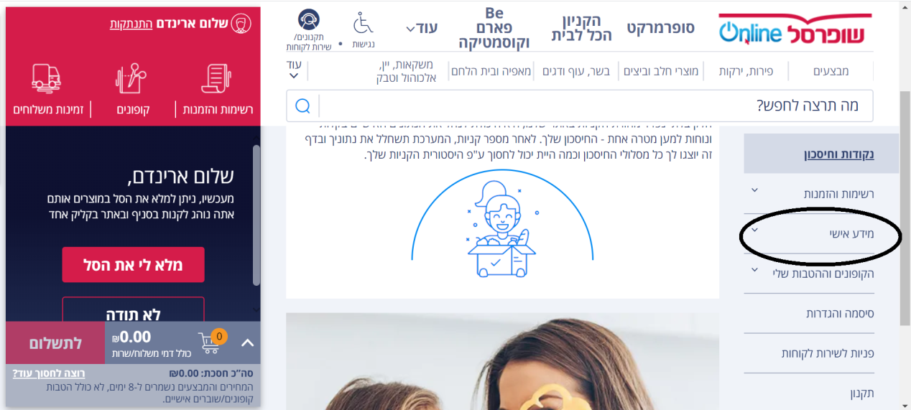
- Then press "addresses" to update your delivery address.
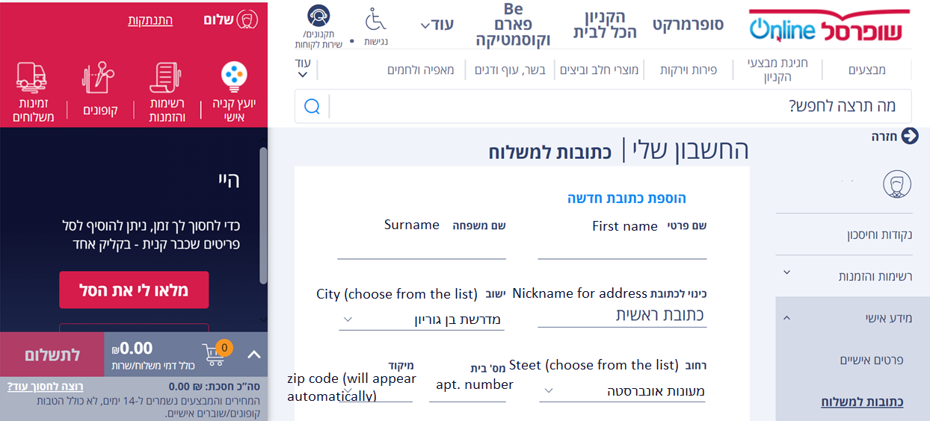
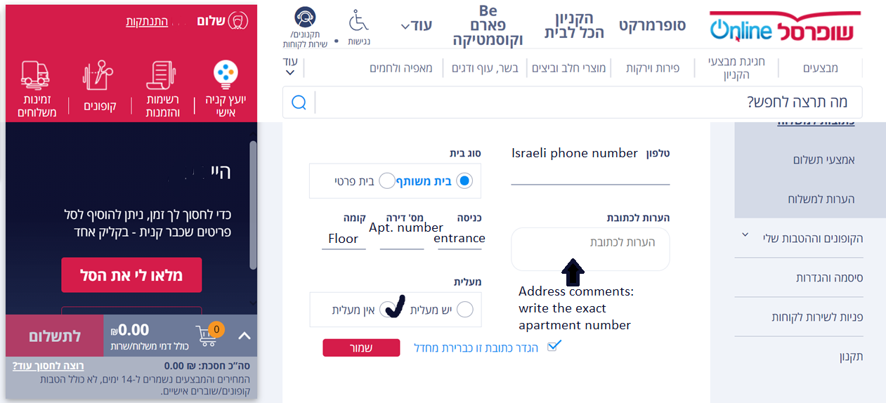

- Then press the payment options and add your details. Note that they don’t accept debit cards.
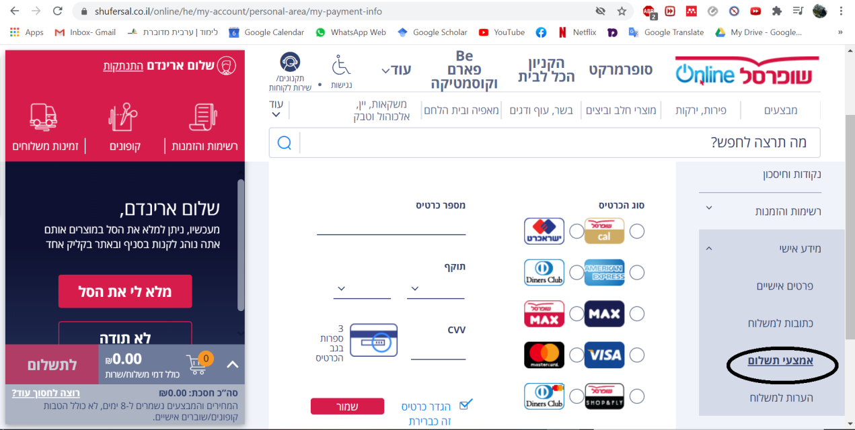

- Go back to the main page to choose your products by pressing the typing a product name in the search line.
- Use google translate to translate the website, but note that you won't find your products written in English so try and translate the name of the product to Hebrew and search through the website.

